**SACRED BLOOD DONATION WEBSITE**

**AIM**

To develop a website on Blood Bank

**PROBLEM STATEMENT**

To develop a Blood Bank Website where the user can make themselves as a blood donor by signing in to the website and registering them as a donor.In case of emergency they can request the required blood by specifying its type and location to deliver it as soon as possible.

**SOFTWARE REQUIREMENT SPECIFICATION**

**1. Introduction**

**1.1 Purpose**

The purpose of a blood bank website is to serve as a central online platform that facilitates the efficient and effective management of blood donations, connects donors with recipients in need of blood transfusions, and provides information and resources related to blood donation and transfusion.

**1.2 Product Scope**

The product scope of a blood bank website refers to the boundaries and features of the website and its functionalities. It defines what the website will and will not include.

**2. Overall Description**

**2.1 Product Perspective**

The product scope of a blood bank website refers to the boundaries and features of the website and its functionalities. It defines what the website will and will not include.

**2.2 Product Functions**

The product functions of a blood bank website refer to the specific features and capabilities it provides to fulfill its intended purpose. The product functions of a blood bank website typically include:

* + 1. **Donor Registration and Profile Management:**
* User Information and personal information
* Donor profile creration and management

**2.2.2 Donor Reciptent Matching:**

* Matching capable blood donors with reciptents in need of specific blood types
* Algorithm matching based on blood type,donation and other factors

**2.3 General Constraints**

General constraints are factors that impose limitations or restrictions on the development and operation of a blood bank website. These constraints can impact various aspects of the website's design, functionality, and deployment

1. **External Interface Requirements**

External interface requirements in the context of a blood bank website refer to the interactions and interfaces the website needs to have with external systems, services, and users. These requirements define how the website will communicate and exchange information with external entities. Some common external interface requirements for a blood bank website include:

**3.1.1 Donor Interface:**

* User registration and login functionality for donors to access their accounts.
* Donor profile management, allowing donors to update their information.
* Blood donation appointment scheduling and management for donors.

**3.1.2 Recipient Interface:**

* Blood request submission interface for recipients or healthcare professionals.
* Matching algorithm to identify suitable donors based on recipient requirements.
* Notification system to inform recipients about donor matches and blood availability.

**3.1.3 Blood Bank Staff Interface:**

* Administrative dashboard for blood bank staff to manage donor and recipient records.
* Staff management features to add, edit, and assign roles to blood bank personnel.

**3.1.4 Messaging and Notifications:**

* Secure messaging system for communication between the blood bank, donors, and recipients.
* Notifications to donors about upcoming blood drives, urgent blood needs, and updates on donation status.
* Notifications to recipients about donor matches and blood availability.

**3.1.5 Integration with External Systems**:

* Integration with hospital or healthcare systems to receive and process blood requests from recipients.
* Integration with external messaging services for communication with donors and recipients.
* Integration with payment gateways or financial systems for processing donations, if applicable.

**3.2 Hardware Interfaces**

Processor : Intel core i3

Process speed : 1.7 GHz

Memory : 4GB

Hard drive : 443

**3.3 Software Interfaces**

Operating system : Windows 7,8,10 or 11

Front End : FIGMA,HTML AND JS

Back End : Mongo DB

**4. System Features**

This system contains 4 modules in it. They are given below:

1. Home

2. Who we are

3. How it works

4. Register as a donor

5. Post Request

6. Blog

7. Contact

1. **UML DIAGRAMS**
2. **Use case Diagram**

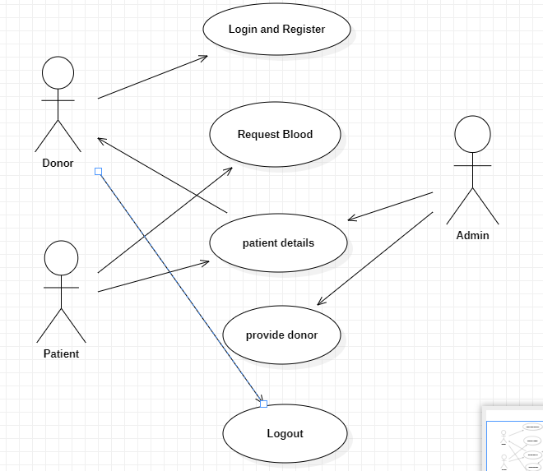

1. **Class Diagram**

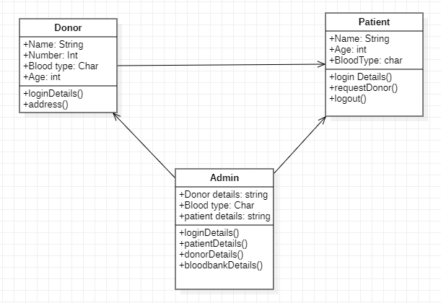

1. **Sequence Diagram**

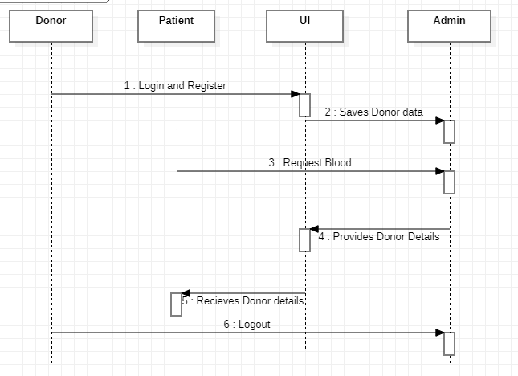

**II. CONCLUSION**

In conclusion, the development of a blood bank website offers significant benefits in streamlining blood donation processes, enhancing communication between stakeholders, and improving the overall efficiency of blood bank operations. By considering the problem statement, purpose, product scope, product perspective, product functions, general constraints, and external interface requirements, a comprehensive and effective blood bank website can be designed and implemented.

The blood bank website serves as a central platform for donor registration, blood inventory management, appointment scheduling, donor-recipient matching, communication, reporting, and educational resources. It facilitates the engagement of donors, ensures accurate tracking of blood inventory, enables efficient matching of donors with recipients, and provides secure communication channels.

However, the development and implementation of a blood bank website must consider general constraints such as budget, time, technology, security, scalability, usability, and compliance with regulations. External interface requirements are also crucial to establish seamless communication and integration with external systems, services, and user interfaces.